An
INDUSTRIAL TRAINING REPORT
on

“PREDICTION OF MULTIPLE DISEASES

USING MACHINE LEARNING TECHNIQUES”

At
Labmentix Edtech Pvt Ltd
8th Semester Industrial Training
Submitted for the partial fulfilment for the award of Degree of
Bachelor of Technology
In Information Technology

Affilated

J. C. Bose University of Science & Technology, YMCA, Faridabad
Session (2021-25)

Submitted By: - PRERNA
University Roll No.: - 21012011018

Under the Guidance of
Mr. Swaraj Phatangade Mr. Narender Singh
( Data Scientist ) ( Project Guide )

B. S. Anangpuria Institute of Technology & Management
Alampur, Faridabad

TRAINING COMPLETION CERTIFICATE

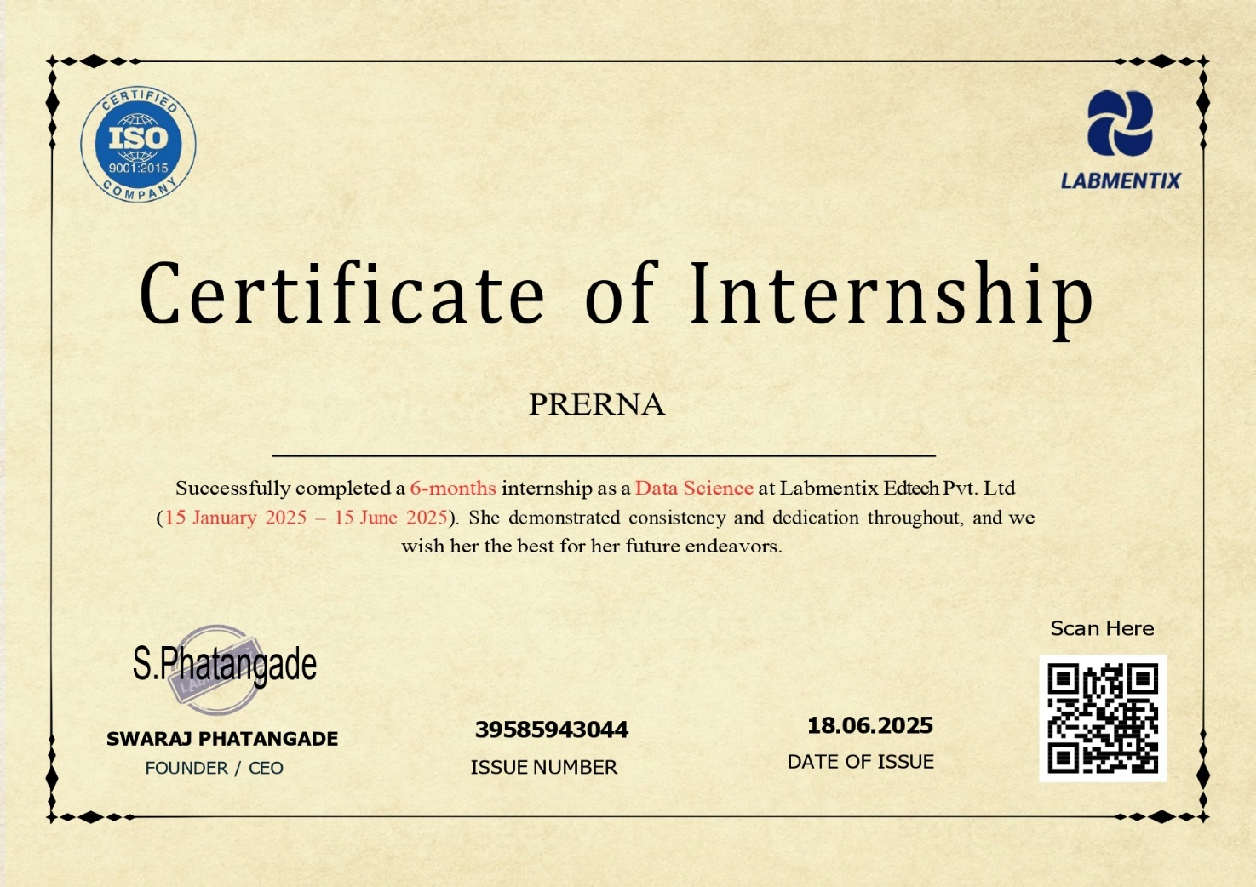

CERTIFICATE

This is to certify that Mr./ Ms. PRERNA, Roll No: 21012011018 student of B. Tech. IT has successfully completed the Industrial Project on work titled “PREDICTION OF MULTIPLE DISEASE USING ML TECHNIQUES ” in partial fulfillment of the requirement of the degree of Bachelor of Technology in Computer Science Engineering or Information Technology as prescribed by J.C. Bose University of Science & Technology, YMCA , Faridabad.
This project report is the record of authentic work carried out by Ms. PRERNA during the period from 15 January 2025 to 15 June 2025 at Labmentix Edtech Pvt Ltd under the supervision of supervisor-I Mr. Swaraj Phatangade and co-supervisor Mr. Narender Singh
The work contained in this report has not been submitted in part or full to any university or institute for the award of any other degree or diploma.

Signature of Supervisor-II
Name: Mr. Narender Singh
Designation:
Date:

Approved By:

(Principal)

DECLARATION

I hereby certify that the work which is presented in this report titled “PREDICTION OF MULTIPLE DISEASE USING ML TECHNIQUES” in partial fulfillment of the requirement of the degree of Bachelor of Technology in Computer Science Engineering/Information Technology and is submitted to the Department of Computer Science Engineering/Information Technology, B. S. Anangpuria Institute of Technology and Management, Faridabad is an record of my own work carried under the supervision of Mr. Swaraj Phatangade and co-supervisor Mr. Narender Singh

The work contained in this report has not been submitted in part or full to any institute for the award of any other degree or diploma.

Place: Noida Student Name: Prerna

Date: 15 January 2025 Roll No.: 21012011018

ACKNOWLEDGEMENT

I am highly indebted to B. S. Anangpuria Institute of Technology & Management. Their guidance and constant supervision as well as for Providing necessary information regarding the project & also for their support in completing the project

Acknowledgement is the perfect way to convey heartiest thanks to all outstanding personalities. I consider myself fortunate to get the opportunity of doing a project, yet the opportunity could not have been utilized without the guidance and support of many individuals.

I register my immense gratitude to project guide Mrs. Monika Gaur, BSAITM.
I am highly indebted to “Mr. Narender Singh” for giving me a rare opportunity to undertake this project.

Finally, I would be failing my duty if I did not put on record my deep sense of obligation to my parents and friends, who provided me with an environment conducive to hard work

Student Name: Prerna

Roll No.: 21012011018

COMPANY PROFILE

Labmentix Edtech Pvt. Ltd. is a professionally driven educational technology company committed to providing students with practical, industry-aligned training through structured virtual internships. The company focuses on equipping learners with hands-on experience in high-demand areas such as Data Science, Artificial Intelligence, Business Intelligence, and Full Stack Development.

With a mission to bridge the gap between academic learning and professional requirements, Labmentix offers project-based internships guided by experienced mentors. These internships replicate real-world workflows and help students build strong technical foundations through the use of tools like Python, SQL, Power BI, and Machine Learning frameworks.

I undertook a 6-month internship with Labmentix in the Data Science domain from 15th January 2025 to 15th June 2025, where I contributed to various projects involving data visualization, model building, and data-driven insights. This opportunity enhanced my skills in end-to-end data handling and applying analytics techniques in real scenarios.

Key Offerings of Labmentix:
- Remote internships across Data Science, AI, BI, and Web Development
- Real-time project experience aligned with industry standards
- Tool proficiency in Python, SQL, Power BI, Excel, and ML libraries
- Personalized mentorship and structured training
- Flexible, remote learning ecosystem with certification

Website: www.labmentix.in


COMPANY INTERNSHIP LETTER

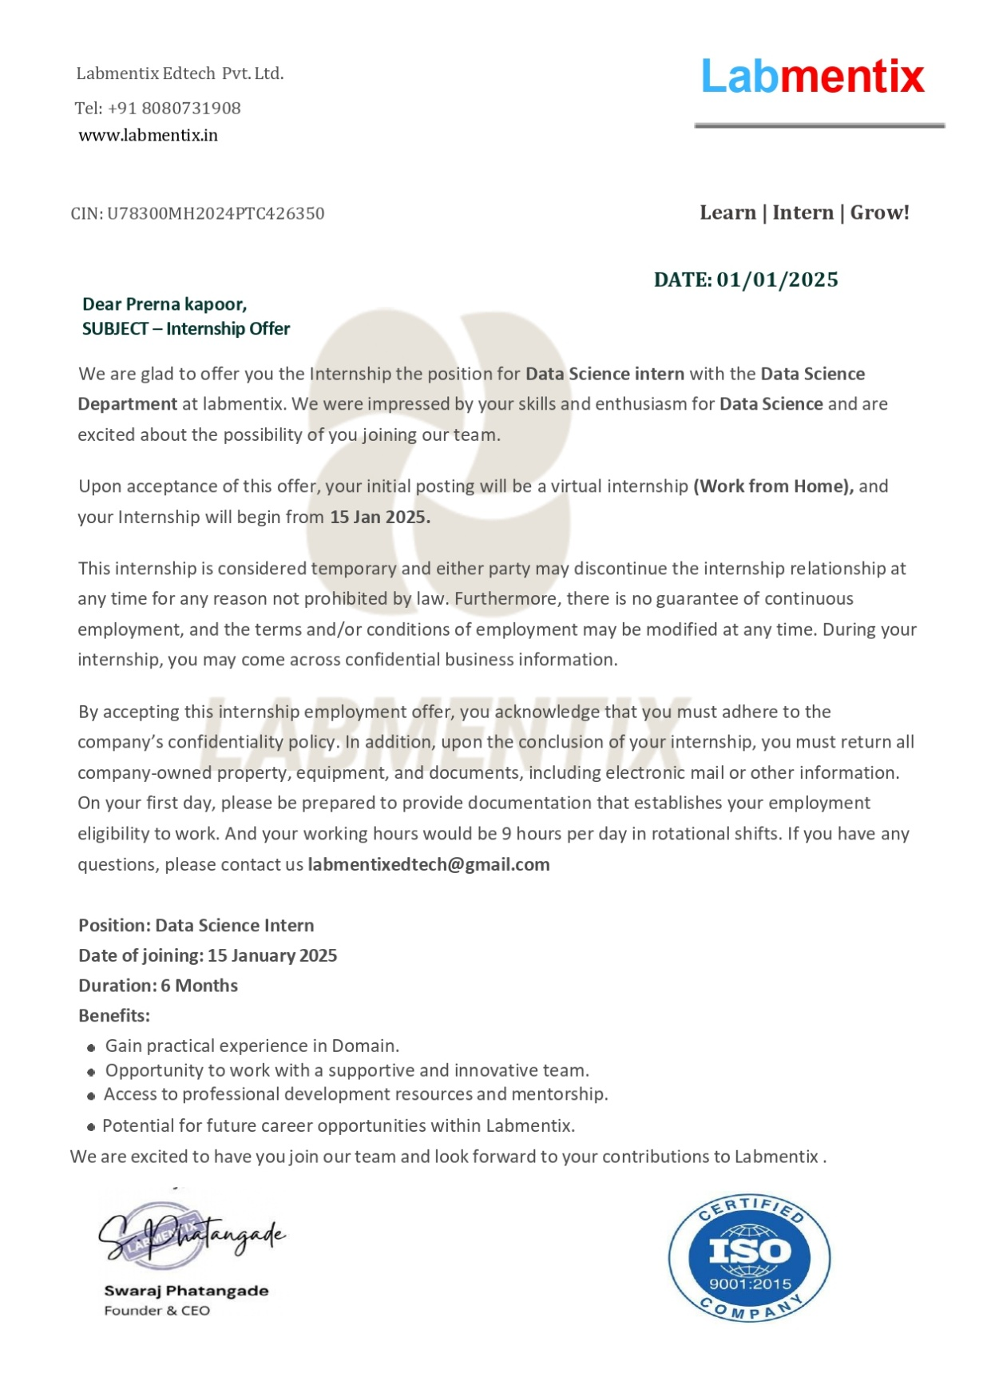
LIST OF FIGURES/GRAPHS

Figure No. | Description |  | Page Number
Figure 1.1 | Amazon Sales Powerbi Dashboard
Figure 1.2 | Superstore Sales Dashboard
Figure 2.1 | Data Flow Diagram
Figure 3.1 | Architecture Diagram
Figure 4.2 | UML Diagram
Figure 4.3 | Class Diagram
Figure 4.4 | Activity Diagram
Figure 4.5 | Sequence Diagram
Figure 4.6 | Collaboration Diagram

LIST OF TABLES

Table | Table Name | Page Number
Table 2.1 | Hardware Specifications | 28
Table 2.2 | Software Specifications | 29
Table 5.1 | Data Dictionary Overview | 43
Table 5.1 | Types of Software Testing | 47

TABLE OF CONTENT

LIST OF CONTENTS S.NO.
Certificate……………………………………………………………………… i - ii
Candidate Declaration…………………………………………………….….… iii Acknowledgement……………………………………………………….,……... iv
Company Profile…………………………………………………….……..…….. v
Company Internship Letter…………………………………………..………. vi
List of Figures/Graphs…………………………….…………………,……….. vii
List Of Tables ………..…………………………….…………………,……….. viii
Chapter 1. | INTRODUCTION
1.1 | Problem Definition
1.2 | Objectives
1.2.1 | Aim of the Project
1.2.2 | Scope of the Project
1.3 | Proposed Algorithm
Chapter 2. | REQUIREMENTS ANALYSIS (SRS)
2.1 | Existing System
2.2 | Proposed System
2.3 | Requirement Analysis
2.4 | Hardware Specification
2.5 | Software Specification
Chapter 3. | DESIGN (High Level Design, DFD Design)
3.1 | ER Diagram
3.2 | UML Diagram
3.3 | Class Diagram
3.4 | Activity Diagram
3.5 | Sequence Diagram
Chapter 4. | MODULE IMPLEMENTATION
4.1 | Software Environment
4.2 | Python
4.3 | History of Python
4.4 | Python Features
4.5 | Getting Python
4.6 | First Python Program
4.7 | Python Install
4.8 | Modules
4.8.1 | Module Description
4.8.2 | Data Collection Module
4.8.3 | Preparing the Data Module
4.8.4 | Training a Model
4.9 | POWERBI
Chapter 5. | DATABASE & DATA DICTIONARY
5.1 | Database
5.2 | Data Dictionary
Chapter 6. | TESTING STRATEGY
6.1 | Types of Testing
Chapter 7. | SNAPSHOT OF GUI
Chapter 8. | REFERENCES
Chapter 9. | STUDENT PROFILE

CHAPTER 1

INTRODUCTION

- The Earth is going through a purplish patch of technology where the demand of intelligence and accuracy is increasing behind it. Today's people are likely addicted to internet but they are not concerned
about their physical health.
- People ignore the small problem and don't visit to visit hospital which turn into serious disease with time. Taking the advantage of this growing technology, our basis aim is to develop such a system that will predict the multiple diseases in accordance with symptoms put down by the patients without visiting the hospitals physicians.
- Machine Learning is a subset of AI that is mainly deal with the study of algorithms which improve with the use of data and experience. Machine Learning has two phases i.e. Training and Testing. Machine Learning provides an efficient platform in medical field to solve various healthcare issues at a much faster rate.
- There are two kinds of Machine Learning – Supervised Learning and Unsupervised Learning. In supervised learning we frame a model with the help of data that is well labelled. On the other hand, unsupervised learning model learn from unlabeled data.
- The intent is to deduce a satisfactory Machine Learning algorithm which is efficient and accurate for the prediction of disease. In this paper, the supervised Machine Learning concept is used for predicting the diseases.
- The main feature will be Machine Learning in which we will be using machine learning algorithm which will help in early prediction of diseases accurately and better patient care.

2ND PROJECT -- > Amazon Sales Power BI Dashboard Project: -
This project is a dynamic Power BI dashboard that analyzes year-wise Amazon sales data from 2012 to 2015. The dashboard offers key business insights through interactive visualizations, including:
- Sales Projection of 4.30M units and KPI indicators like product units sold (3418), total returns (371), and performance metric (61K).
- Segment-wise and Market-wise Sales Distribution, helping understand customer behavior across Consumer, Corporate, and Home Office segments.
- Geographical Profit Analysis using pie charts showing profit contribution by countries and cities (e.g., United States, India, China).
- Top and Bottom Product Profit visualizations, identifying best-selling products like "Canon" and least profitable ones.
- Customer Profitability Analysis revealing top customers generating the highest profit.
The dashboard helps stakeholders make data-driven decisions by monitoring performance, tracking KPIs, and identifying improvement areas using clean and vibrant visual analytics.

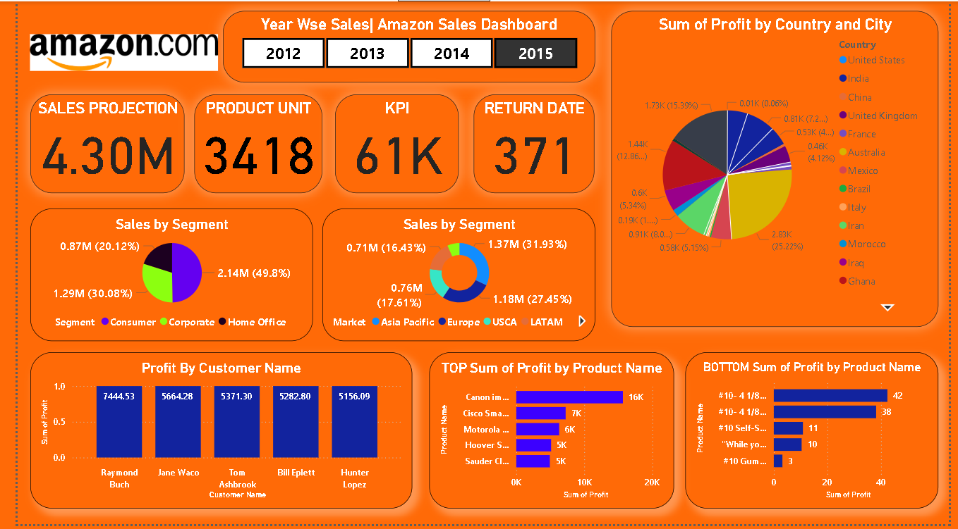
Fig 1.1

3rd PROJECT –Super Store Sales Power BI Dashboard Project
This interactive Power BI dashboard provides comprehensive insights into Super Store sales and profitability across different regions, categories, and timeframes for the years 2019 and 2020. Key features include:
- Sales and Profit Trends by state, month, and year, helping in time-series analysis and seasonal patterns.
- Product Analysis through sub-category and category-wise sales visuals—showing top-performing items like Chairs, Binders, and Phones.
- Shipping Insights that highlight customer preference for Standard Class mode contributing 0.21M in sales.
- Customer Segmentation with sales share from Consumer (47.63%), Corporate (32.53%), and Home Office (19.84%).
- Payment Mode Analysis revealing COD as the dominant mode (40.51%), followed by Online and Card payments.
- Key KPIs displayed: Total Sales (0.34M), Quantity (5K), and Average Delivery Time (4.04 days).
- Regional Sales Distribution using filters and donut charts for focused decision-making.
The dashboard empowers users to drill down insights, monitor business performance, and make informed strategic decisions.
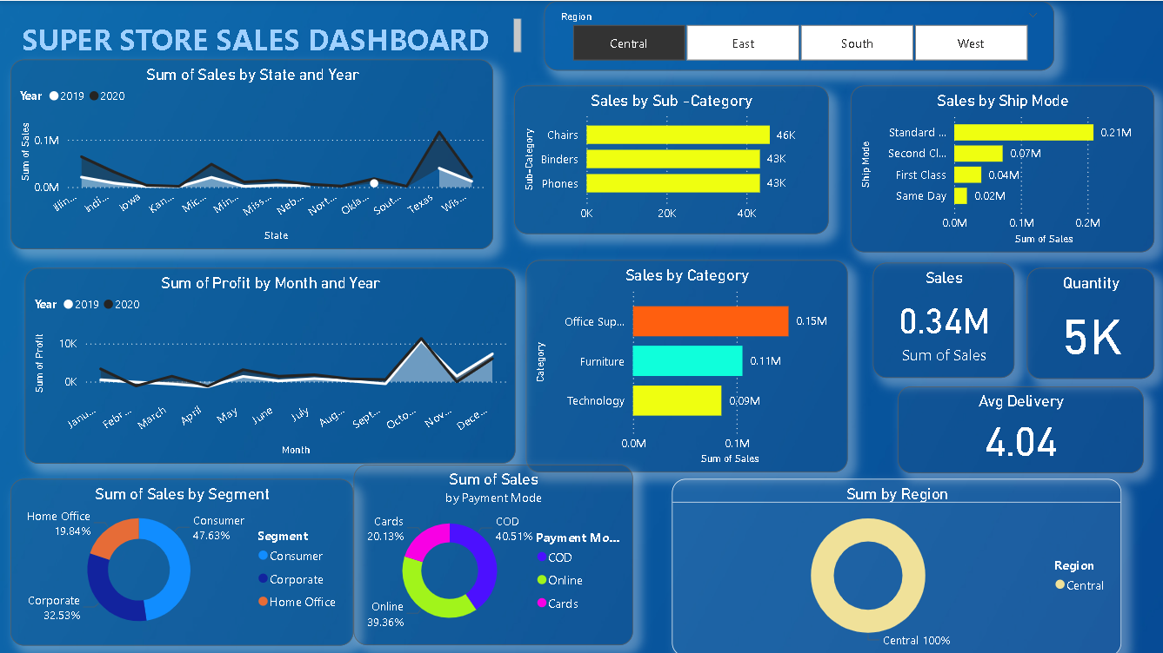
Fig – 1.2

1.1 PROBLEM DEFINITION

The smart health prediction system focused for optimally reducing the healthcare costs. There are several functionalities remain untouched into health prediction system. So by living in the edge of technology and still if we are not able to utilize it in efficient and proper manner then there is no use of it. To tackle this, research is carried out in health prediction system. There are several applications which use any one of the technology. This project shows the merging of both technologies to achieve efficient result.

1.2 OBJECTIVES

1.2.1 Aim of the Project:

- The analysis accuracy is reduced when the quality of medical data in incomplete.
- Moreover, different regions exhibit unique characteristics of certain regional diseases, which may weaken the prediction of disease outbreaks.
- However, those existing work mostly considered structured data.

- There is no proper methods to handle semi structured and unstructured.

- The proposed system will consider both structured and unstructured data.

- The analysis accuracy is increased by using Machine Learning algorithm.

1.2.2 Scope of the Project
- In this work, our goal is to provide a tool to assist professionals and consumers in finding and choosing disease.
- To achieve this goal, we develop an approach that allows a user to query for disease that satisfy a set of conditions based on disease properties, such as disease indications and also takes into account patient profiles

1.3. PROPOSED ALGORITHM
• Logistic Regression

1.3.1 ARCHITECTURE DIAGRAM

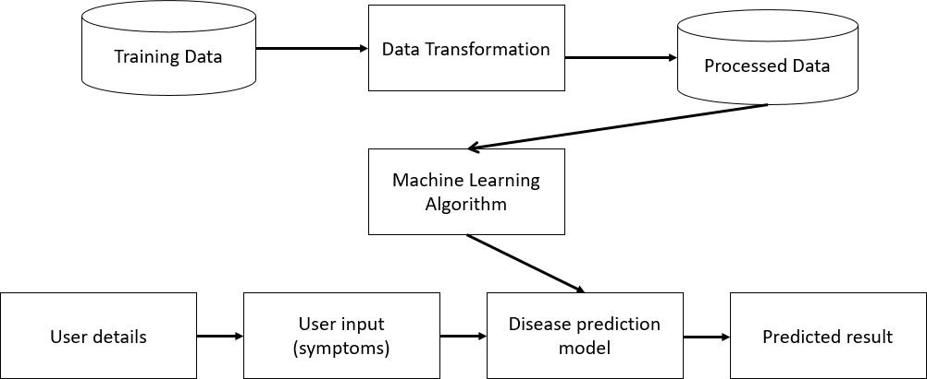

Fig 1.1- ARCHITECTRE DIAGRAM

Chapter 2

REQUIREMENTS ANALYSIS (SRS )

System Analysis is the first stage in the System Development Life Cycle (SDLC). It involves a comprehensive study of existing systems and defining the necessary improvements to achieve project goals.
For the Multiple Disease Prediction System, analysis includes understanding how symptoms and datasets can be used effectively for disease prediction using Machine Learning. The process involves identifying the boundaries of the current healthcare prediction systems and analyzing their limitations. The analysis also includes understanding how machine learning models interact with datasets, user input, and the prediction engine.
Logical system modeling tools such as flowcharts, data flow diagrams (DFDs), and UML diagrams are essential during analysis. Analytical skills, domain knowledge, and practical experience are required to understand the functionality and gather the necessary system requirements.

2.1 EXISTING SYSTEM

In the current system, basic disease prediction systems exist, but they have multiple limitations:
- They predict only primary diseases and not the sub-types or related conditions.
- They are often limited to structured data only.
- Many systems are costly and inaccessible to the general public.
- The predictions are often broad and vague, lacking specificity.
- There is no personalized risk analysis or detailed recommendations.
- Most systems cannot handle multiple diseases or their co-relation.

2.2 Proposed System
The proposed Multiple Disease Prediction System overcomes the above limitations by:
- Accepting multiple symptoms from the user.
- Comparing inputs with a predefined medical dataset.
- Using Machine Learning algorithms like Logistic Regression for accurate prediction.
- Displaying probability-based outputs to users with risk percentages.
- Offering recommendations based on final results.
- Predicting diseases like Covid-19, Chronic Kidney Disease, and Heart Disease.

2.3 Requirement Analysis

- Requirement Analysis is a critical step that defines the functional and non-functional aspects of the project. It helps in understanding what the system should do and how it should behave. For this project, the aim is to deliver a scalable and intelligent medical prediction system.

- This phase includes the following Four areas:

- Problem Recognition - Existing prediction systems fail to address the complexity of diseases and their inter-relations. There's also a lack of personalized results.

- Modeling - We use data flow diagrams and algorithms to show how symptoms are collected, processed, and converted into predictions.

- Specification - The system must support:
  - Symptom input interface
  - Dataset mapping
2.4 Hardware Specification

Component | Specification
C.P.U. | Pentium i3 or above
Memory | 2 GB RAM or higher
Monitor | Mono/Color
Keyboard | Standard/Low profile
I/O Devices | Mouse, Monitor
Operating System | Windows 7 or above

2.5 Software Specification

Category | Specification
Front End | React JS
Backend (ML Model) | Python (Logistic Regression)
Development Tool | Visual Studio Code
Dataset Format | CSV/Excel
Libraries Used | Pandas, Scikit-learn, NumPy
Operating System | Windows/Linux

Chapter 3.

DESIGN ( HIGH LEVEL DESIGN DATA FLOW DIAGRAM DESIGN)

- The DFD is also called as bubble chart. It is a simple graphical formalism that can be used to represent a system in terms of input data to the system, various processing carried out on this data, and the output data is generated by this system.

- The data flow diagram (DFD) is one of the most important modeling tools. It is used to model the system components. These components are the system process, the data used by the process, an external entity that interacts with the system and the information flows in the system.

- DFD shows how the information moves through the system and how it is modified by a series of transformations. It is a graphical technique that depicts information flow and the transformations that are applied as data moves from input to output.

- DFD is also known as bubble chart. A DFD may be used to represent a system at any level of abstraction. DFD may be partitioned into levels that represent increasing information flow and functional detail.

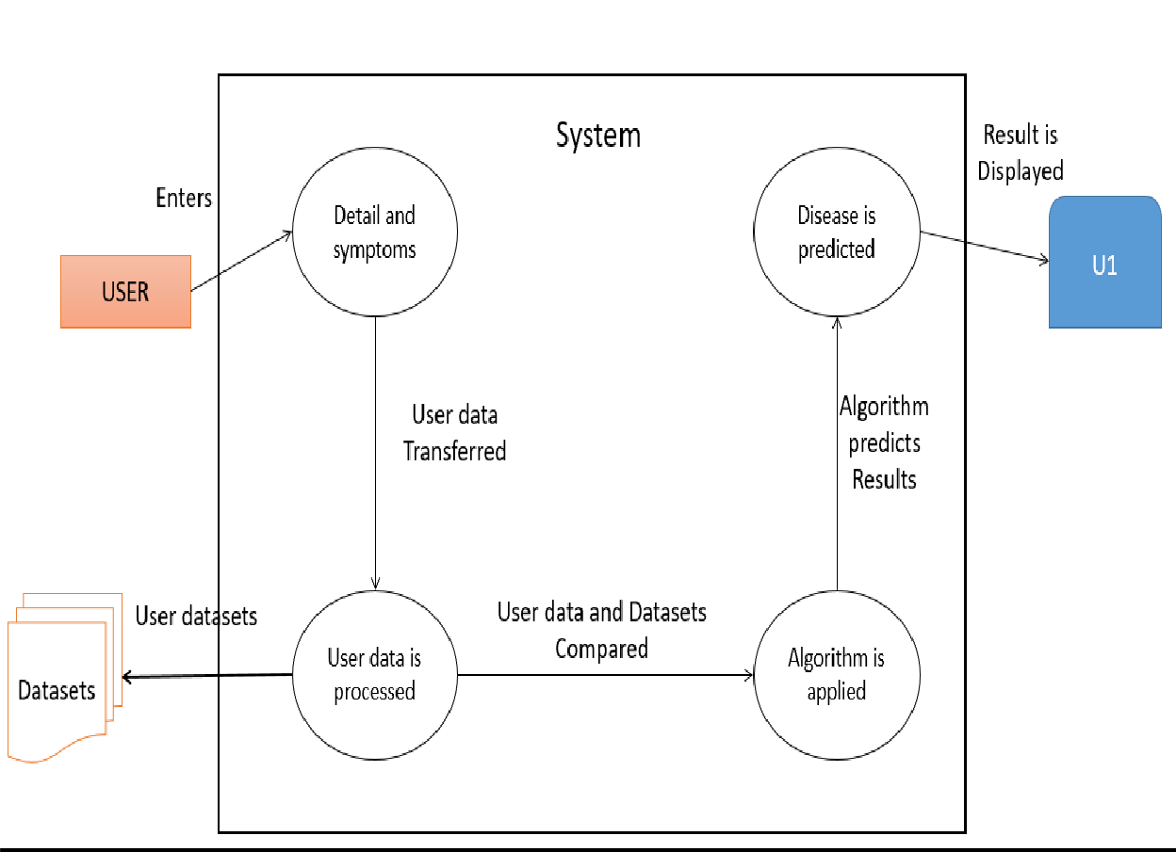
Fig 3.1- Data flow Diagram

3.1 ER- DIAGRAM
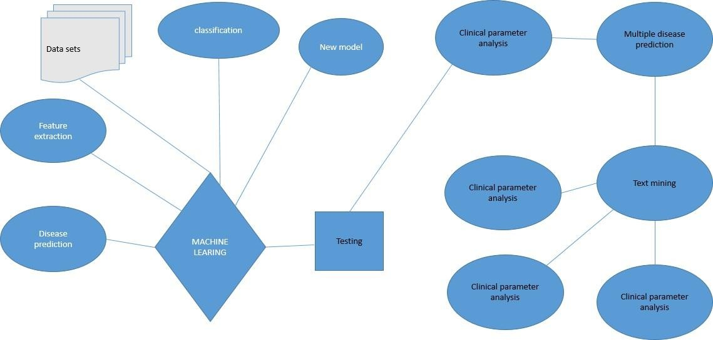

Fig 3.1- ER-Diagram

3.2 UML DIAGRAM
UML is a method for describing the system architecture in detail using the blueprint. UML represents a collection of best engineering practices that have proven successful in the modeling of large and complex systems. UML is a very important part of developing objects oriented software and the software development process.

User

Registration

Doctor appointment
for

corresponding

disease

Sever

Deployment

Gives

symptoms

Analysis

Of

Patient

health

User

Server

Analysis

of

Questionaries

Disease

Anlaysis

Suggest

best

drug

Fig 3.2- UML Diagram

3.3 CLASS DIAGRAM

Class diagrams are widely used to describe the types of objects in a system and their relationships. Class diagrams model class structure and contents using design elements such as classes, packages and objects. Class diagrams describe three different perspectives when designing a system, conceptual, specification, and implementation. These perspectives become evident as the diagram is created and help solidify the design. Class diagrams are arguably the most used UML diagram type. It is the main building block of any object oriented solution. It shows the classes in a system, attributes and operations of each class and the relationship between each class. In most modeling tools a class has three parts, name at the top, attributes in the middle and operations or methods at the bottom. In large systems with many classes related classes are grouped together to create class diagrams. Different relationships between diagrams are show by different types of Arrows. Below is a image of a class diagram. Follow the link for more class diagram examples.

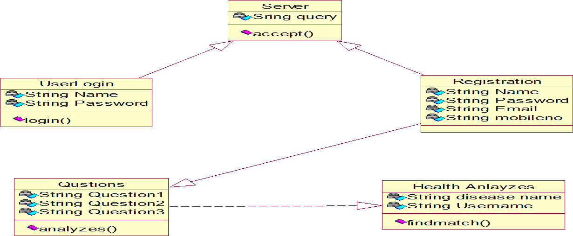

Fig 3.3- Class Diagram

3.4. ACTIVITY DIAGRAM
Activity diagrams describe the workflow behavior of a system. Activity diagrams are similar to state diagrams because activities are the state of doing something. The diagrams describe the state of activities by showing the sequence of activities performed. Activity diagrams can show activities that are conditional or parallel.

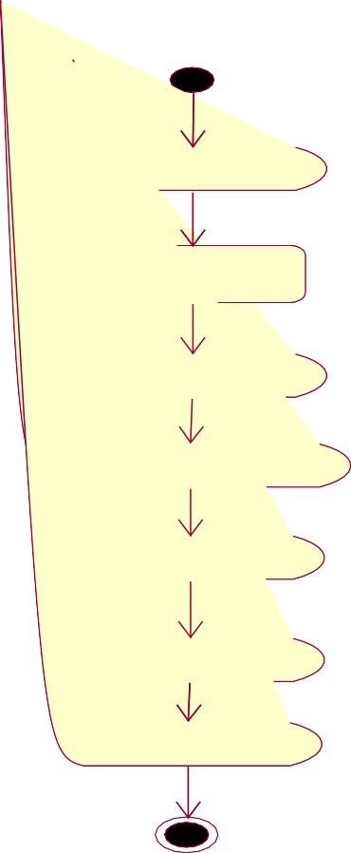
Login

Disease

Server

Analysis of Patient

Health

Condition

Formulation

Questions

Evidence

Gathering

Resultant

Output

Fig 3.4- Activity Diagram

3.5. SEQUENCE DIAGRAM

Sequence diagrams in UML shows how object interact with each other and the order those interactions occur. It‟s important to note that they show the interactions for a particular scenario. The processes are represented vertically and interactions are show as arrows. This article explains the purpose and the basics of Sequence diagrams.

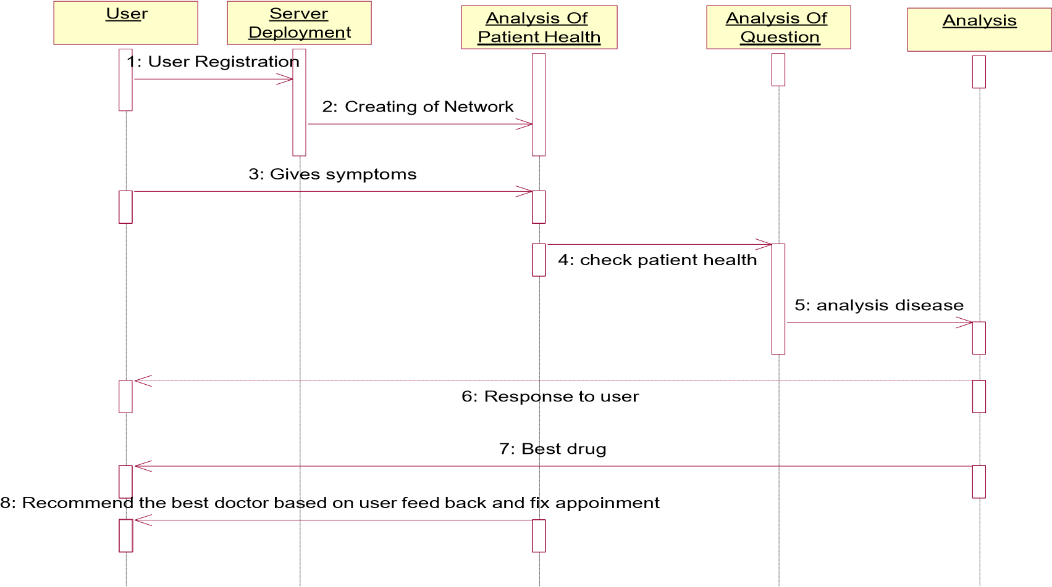
Fig 3.5- Sequence Diagram

3.6. COLLABORATION DIAGRAM

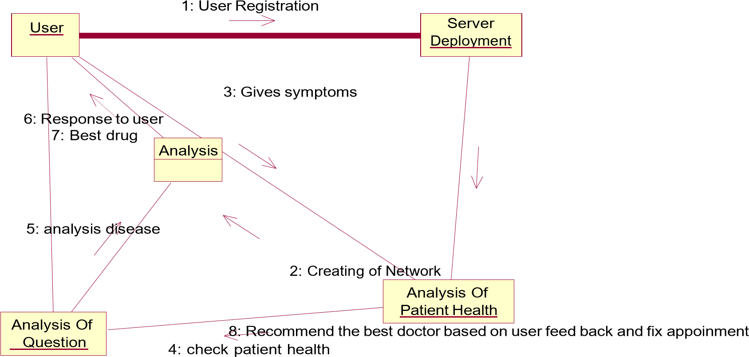

Fig 3.6- Collaboration Diagram

Chapter 4

INFORMATION ABOUT MODULE IMPLEMENTED BY STUDENT

4.1 Python:

Python is a high-level, interpreted, interactive and object-oriented scripting language. Python is designed to be highly readable. It uses English keywords frequently where as other languages use punctuation, and it has fewer syntactical constructions than other languages.
- Python is Interpreted − Python is processed at runtime by the interpreter. You do not need to compile your program before executing it. This is similar to PERL and PHP.
- Python is Interactive − You can actually sit at a Python prompt and interact with the interpreter directly to write your programs.
- Python is Object-Oriented − Python supports Object-Oriented style or technique of programming that encapsulates code within objects.
- Python is a Beginner's Language − Python is a great language for the beginner-level programmers and supports the development of a wide range of applications from simple text processing to WWW browsers to games.

4.2 History of Python

Python was developed by Guido van Rossum in the late eighties and early nineties at the National Research Institute for Mathematics and Computer Science in the Netherlands.
Python is derived from many other languages, including ABC, Modula-3, C, C++, Algol-68, SmallTalk, and Unix shell and other scripting languages.
Python is copyrighted. Like Perl, Python source code is now available under the GNU General Public License (GPL).
Python is now maintained by a core development team at the institute, although Guido van Rossum still holds a vital role in directing its progress.

4.3 Python Features

Python's features include −

- Easy-to-learn − Python has few keywords, simple structure, and a clearly defined syntax. This allows the student to pick up the language quickly.
- Easy-to-read − Python code is more clearly defined and visible to the eyes.

- Easy-to-maintain − Python's source code is fairly easy-to-maintain.

- A broad standard library − Python's bulk of the library is very portable and cross-platform compatible on UNIX, Windows, and Macintosh.
- Interactive Mode − Python has support for an interactive mode which allows interactive testing and debugging of snippets of code.
- Portable − Python can run on a wide variety of hardware platforms and has the same interface on all platforms.
- Extendable − You can add low-level modules to the Python interpreter. These modules enable programmers to add to or customize their tools to be more efficient.
- Databases − Python provides interfaces to all major commercial databases.
- GUI Programming − Python supports GUI applications that can be created and ported to many system calls, libraries and windows systems, such as Windows MFC, Macintosh, and the X Window system of Unix.
- Scalable − Python provides a better structure and support for large programs than shell scripting.
Apart from the above-mentioned features, Python has a big list of good features, few are listed below −
- It supports functional and structured programming methods as well as OOP.

- It can be used as a scripting language or can be compiled to byte-code for building large applications.
- It provides very high-level dynamic data types and supports dynamic type checking.
- It supports automatic garbage collection.

- It can be easily integrated with C, C++, COM, ActiveX, CORBA, and Java.

Python is available on a wide variety of platforms including Linux and Mac OS X. Let's understand how to set up our Python environment.

4.4 Getting Python
The most up-to-date and current source code, binaries, documentation, news, etc., is available on the official website of Python https://www.python.org.
Windows Installation

Here are the steps to install Python on Windows machine.

- Open a Web browser and go to https://www.python.org/downloads/.
- Follow the link for the Windows installer python-XYZ.msifile where XYZ is the version you need to install.
- To use this installer python-XYZ.msi, the Windows system must support Microsoft Installer 2.0. Save the installer file to your local machine and then run it to find out if your machine supports MSI.
- Run the downloaded file. This brings up the Python install wizard, which is really easy to use. Just accept the default settings, wait until the install is finished, and you are done.
The Python language has many similarities to Perl, C, and Java. However, there are some definite differences between the languages.

4.5 First Python Program
Let us execute programs in different modes of programming.

Interactive Mode Programming
Invoking the interpreter without passing a script file as a parameter brings up the following prompt −

$ python
Python2.4.3(#1,Nov112010,13:34:43)
[GCC 4.1.220080704(RedHat4.1.2-48)] on linux2

Type"help","copyright","credits"or"license"for more information.

>>>
Type the following text at the Python prompt and press the Enter −
>>>print"Hello, Python!"

If you are running new version of Python, then you would need to use print statement with parenthesis as in print ("Hello, Python!");. However in Python version 2.4.3, this produces the following result −
Hello, Python!

Script Mode Programming

Invoking the interpreter with a script parameter begins execution of the script and continues until the script is finished. When the script is finished, the interpreter is no longer active.
Let us write a simple Python program in a script. Python files have extension .py. Type the following source code in a test.py file −
print"Hello, Python!"
We assume that you have Python interpreter set in PATH variable. Now, try to run this program as follows −
$ python test.py
This produces the following result −
Hello, Python!
What is Python?
Python is a popular programming language. It was created in 1991 by Guido van Rossum.
It is used for:
- web development (server-side),
- software development,
- mathematics,
- system scripting.
What can Python do?
- Python can be used on a server to create web applications.
- Python can be used alongside software to create workflows.
- Python can connect to database systems. It can also read and modify files.
- Python can be used to handle big data and perform complex mathematics.
- Python can be used for rapid prototyping, or for production-ready software development.
Why Python?
- Python works on different platforms (Windows, Mac, Linux, Raspberry Pi, etc).
- Python has a simple syntax similar to the English language.
- Python has syntax that allows developers to write programs with fewer lines than some other programming languages.
- Python runs on an interpreter system, meaning that code can be executed as soon as it is written. This means that prototyping can be very quick.
- Python can be treated in a procedural way, an object-orientated way or a functional way.
Good to know
- The most recent major version of Python is Python 3, which we shall be using in this tutorial. However, Python 2, although not being updated with anything other than security updates, is still quite popular.
- In this tutorial Python will be written in a text editor. It is possible to write
Python in an Integrated Development Environment, such as Thonny, Pycharm, Netbeans or Eclipse which are particularly useful when managing larger collections of Python files.
Python Syntax compared to other programming languages
- Python was designed to for readability, and has some similarities to the English language with influence from mathematics.
- Python uses new lines to complete a command, as opposed to other programming languages which often use semicolons or parentheses.
- Python relies on indentation, using whitespace, to define scope; such as the scope of loops, functions and classes. Other programming languages often use curly-brackets for this purpose.

4.6. Python Install
Many PCs and Macs will have python already installed.

To check if you have python installed on a Windows PC, search in the start bar for Python or run the following on the Command Line (cmd.exe):

C:\Users\Your Name>python --version
To check if you have python installed on a Linux or Mac, then on linux open the command line or on Mac open the Terminal and type:

python --version
If you find that you do not have python installed on your computer, then you can download it for free from the following website: https://www.python.org/

Python Quickstart
Python is an interpreted programming language, this means that as a developer you write Python (.py) files in a text editor and then put those files into the python interpreter to be executed.
The way to run a python file is like this on the command line:

C:\Users\Your Name>python helloworld.py
Where "helloworld.py" is the name of your python file.
Let's write our first Python file, called helloworld.py, which can be done in any text editor.
helloworld.py
print("Hello, World!")
Simple as that. Save your file. Open your command line, navigate to the directory where you saved your file, and run:

C:\Users\Your Name>python helloworld.py
The output should read:

Hello, World!
Congratulations, you have written and executed your first Python program.

The Python Command Line
To test a short amount of code in python sometimes it is quickest and easiest not to write the code in a file. This is made possible because Python can be run as a command line itself.

Type the following on the Windows, Mac or Linux command line:

C:\Users\Your Name>python
From there you can write any python, including our hello world example from earlier in the tutorial:

C:\Users\Your Name>python
Python 3.6.4 (v3.6.4:d48eceb, Dec 19 2017, 06:04:45) [MSC v.1900 32 bit
(Intel)] on win32
Type "help", "copyright", "credits" or "license" for more information. >>> print("Hello, World!")
Which will write "Hello, World!" in the command line:

C:\Users\Your Name>python
Python 3.6.4 (v3.6.4:d48eceb, Dec 19 2017, 06:04:45) [MSC v.1900 32 bit
(Intel)] on win32
Type "help", "copyright", "credits" or "license" for more information.
>>> print("Hello, World!") Hello, World!
Whenever you are done in the python command line, you can simply type the following to quit the python command line interface:

exit()

Execute Python Syntax
As we learned in the previous page, Python syntax can be executed by writing directly in the Command Line:
>>> print("Hello, World!")
Hello, World!
Or by creating a python file on the server, using the .py file extension, and running it in the Command Line:
C:\Users\Your Name>python myfile.py

Python Indentations
Where in other programming languages the indentation in code is for readability only, in Python the indentation is very important. Python uses indentation to indicate a block of code.
Example
if 5 > 2:
print("Five is greater than two!")
Python will give you an error if you skip the indentation: Example if 5 > 2:
print("Five is greater than two!")

4.7 MODULES

- Data Collection Module

- Preparing the data Module

- Training a model

- Disease prediction Module

MODULE DESCRIPTIONS

4.7.1 Data Collection Module
Be it the raw data from excel, access, text files etc., this step (gathering past data) forms the foundation of the future learning. The better the variety, density and volume of relevant data, better the learning prospects for the machine becomes.

4.72 Preparing the data Module
Any analytical process thrives on the quality of the data used. One needs to spend time determining the quality of data and then taking steps for fixing issues such as missing data and treatment of outliers. Exploratory analysis is perhaps one method to study the nuances of the data in details thereby burgeoning the nutritional content.

4.73 Training a model
This step involves choosing the appropriate algorithm and representation of data in the form of the model. The cleaned data is split into two parts – train and test .

Chapter 5.
DATABASE, DATA DICTIONARY

5. 1 Database
In the Multiple Disease Prediction system, the database plays a vital role in storing and organizing medical data required for disease prediction. It consists of structured datasets where each row represents a patient case and columns represent various symptoms, test results, and diagnosed diseases. The database integrates multiple publicly available datasets such as those related to Chronic Kidney Disease, Heart Disease, and COVID-19. Each symptom is encoded numerically (e.g., 1 for present, 0 for absent) to facilitate machine learning processing. The data is cleaned and preprocessed to handle missing values, remove inconsistencies, and normalize the format. This structured database is used to train, validate, and test the machine learning model to ensure accurate predictions. It supports real-time symptom input by users and compares it with historical data for disease estimation. The database also stores the probability scores generated by the model for each disease. CSV files are primarily used, and SQL queries or Python scripts manage the data operations.

5.2 Data Dictionary

The data dictionary provides a comprehensive description of the variables used in the dataset for the Multiple Disease Prediction system. It defines each attribute such as 'age', 'blood_pressure', 'cough', 'fever', and 'disease', along with their data types, expected values, and meanings. For example, attributes like 'fever' or 'cough' are binary, with 1 indicating presence and 0 indicating absence of symptoms. Continuous variables like 'age' or 'blood_pressure' are represented numerically. The target variable ‘disease’ includes categorical values such as “Diabetes”, “COVID-19”, and “Heart Disease”. The dictionary also specifies the data format, value ranges, units (e.g., temperature in °F), and how missing data is handled. It ensures consistency during data entry, model training, and evaluation by acting as a reference guide for developers and analysts. A well-structured data dictionary simplifies debugging and allows easy future modifications or integration of new features.

Chapter 6.

INFORMTION ABOUT TESTING STRATEGY

6.1 SYSTEM TESTING
The purpose of testing is to discover errors. Testing is the process of trying to discover every conceivable fault or weakness in a work product. It provides a way to check the functionality of components, sub assemblies, assemblies and/or a finished product It is the process of exercising software with the intent of ensuring that the
Software system meets its requirements and user expectations and does not fail in an unacceptable manner. There are various types of test. Each test type addresses a specific testing requirement.

6.1.1 TYPES OF TESTS
Unit testing
Unit testing involves the design of test cases that validate that the internal program logic is functioning properly, and that program inputs produce valid outputs. All decision branches and internal code flow should be validated. It is the testing of individual software units of the application .it is done after the completion of an individual unit before integration.
Integration testing
Integration tests are designed to test integrated software components to determine if they actually run as one program. Testing is event driven and is more concerned with the basic outcome of screens or fields.
Functional test
Functional tests provide systematic demonstrations that functions tested are available as specified by the business and technical requirements, system documentation, and user manuals.
Functional testing is centered on the following items:
Valid Input : identified classes of valid input must be accepted.
Invalid Input | : identified classes of invalid input must be rejected.
Functions | : identified functions must be exercised.
Output | : identified classes of application outputs must be exercised.

System Test
System testing ensures that the entire integrated software system meets requirements. It tests a configuration to ensure known and predictable results. An example of system testing is the configuration oriented system integration test. System testing is based on process descriptions and flows, emphasizing pre-driven process links and integration points.
White Box Testing
White Box Testing is a testing in which in which the software tester has knowledge of the inner workings, structure and language of the software, or at least its purpose. It is purpose. It is used to test areas that cannot be reached from a black box level.
Black Box Testing
Black Box Testing is testing the software without any knowledge of the inner workings, structure or language of the module being tested. Black box tests, as most other kinds of tests, must be written from a definitive source document, such as specification or requirements document, such as specification or requirements document. It is a testing in which the software under test is treated, as a black box
.you cannot “see” into it. The test provides inputs and responds to outputs without considering how the software works.
Unit Testing:
Unit testing is usually conducted as part of a combined code and unit test phase of the software lifecycle, although it is not uncommon for coding and unit testing to be conducted as two distinct phases.
Test strategy and approach
Test objectives
- All field entries must work properly.
- Pages must be activated from the identified link.

Chapter7.
SNAPSHOTS OF GUI

POWERBI DASHBOARD :-
- AMAZON SALES DASHBOARD USING POWERBI
- Super Store Sales Power BI Dashboard Project
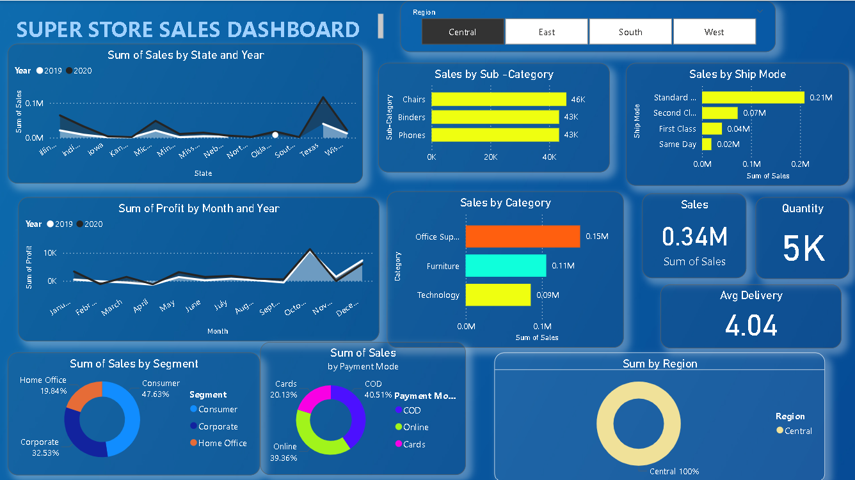

3RD.) MULTIPLE DISEASE PREDICFTION USING PYTHON , MACHINE LEANING

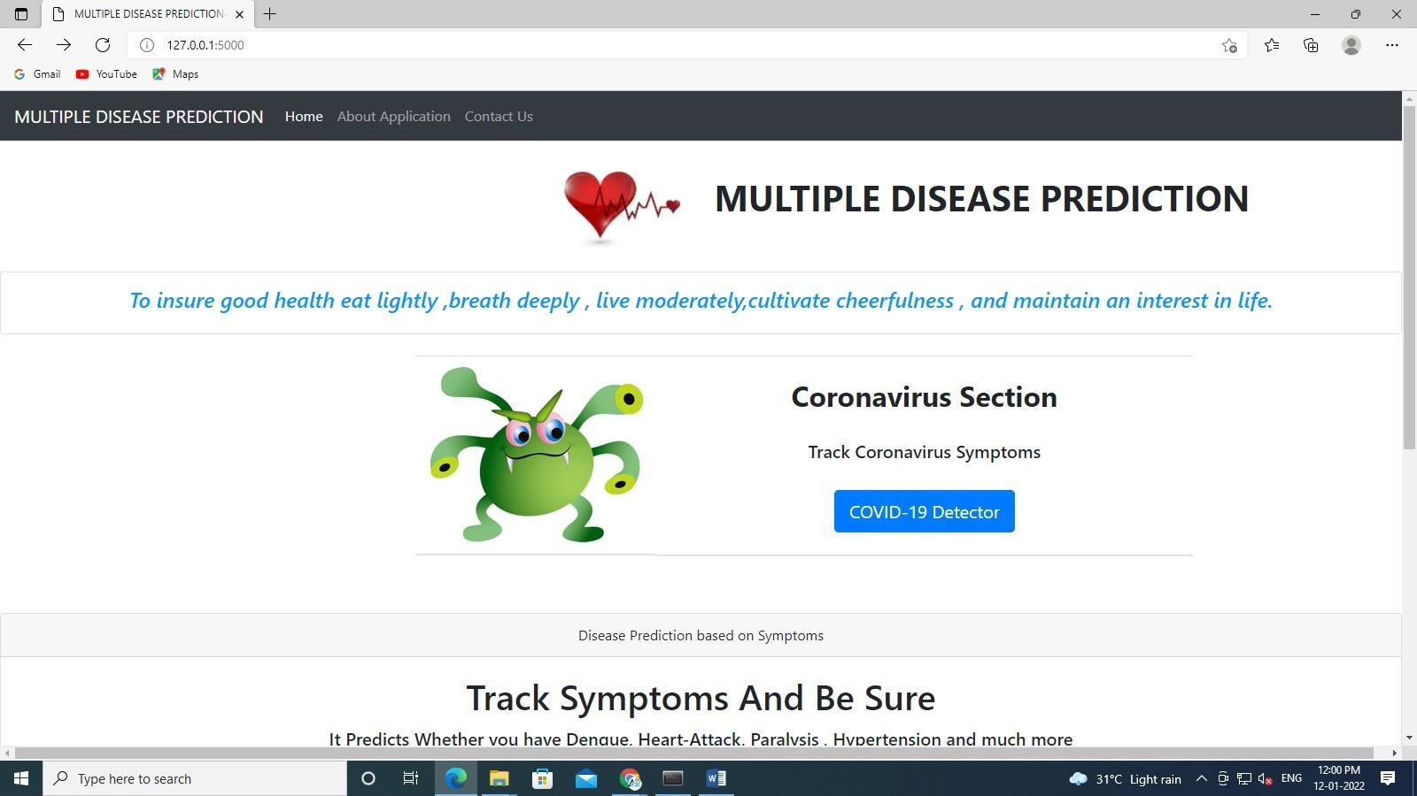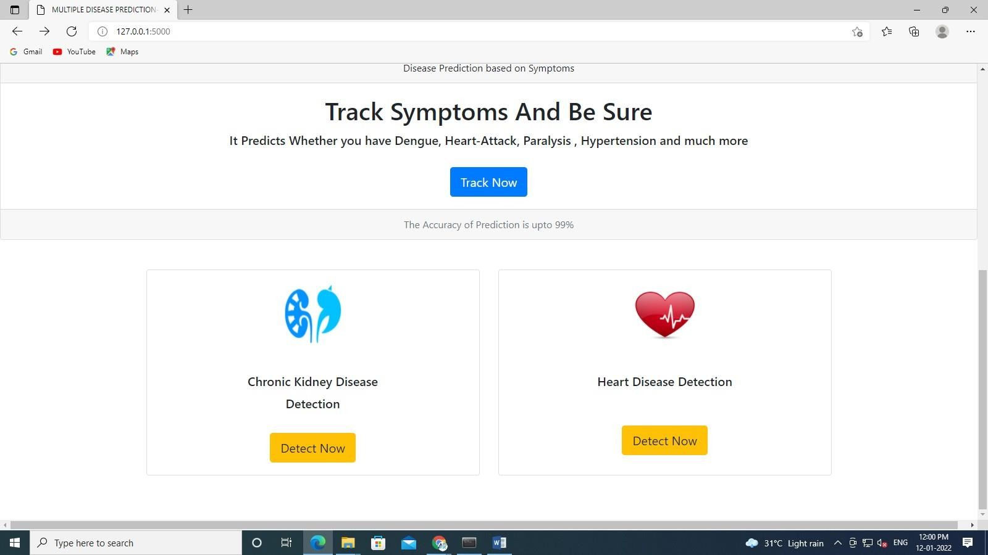

Covid-19 Detector Safe Zone

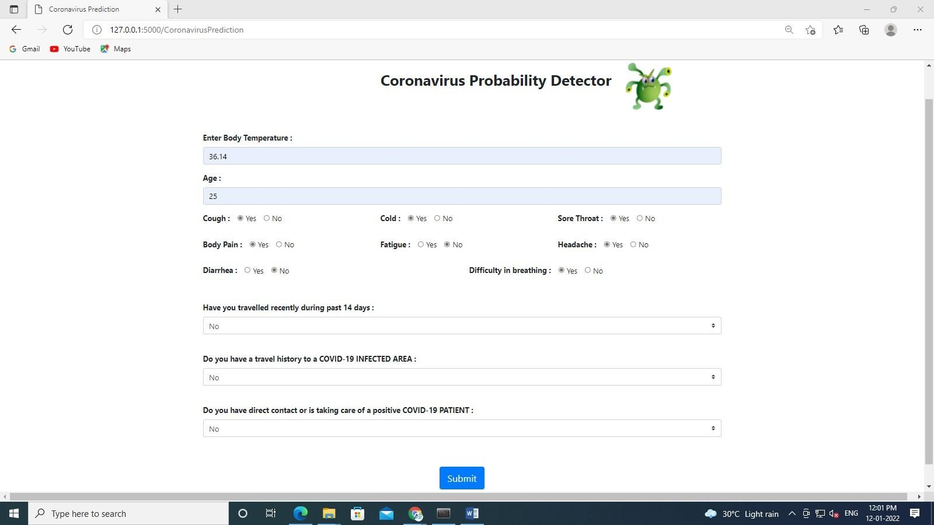

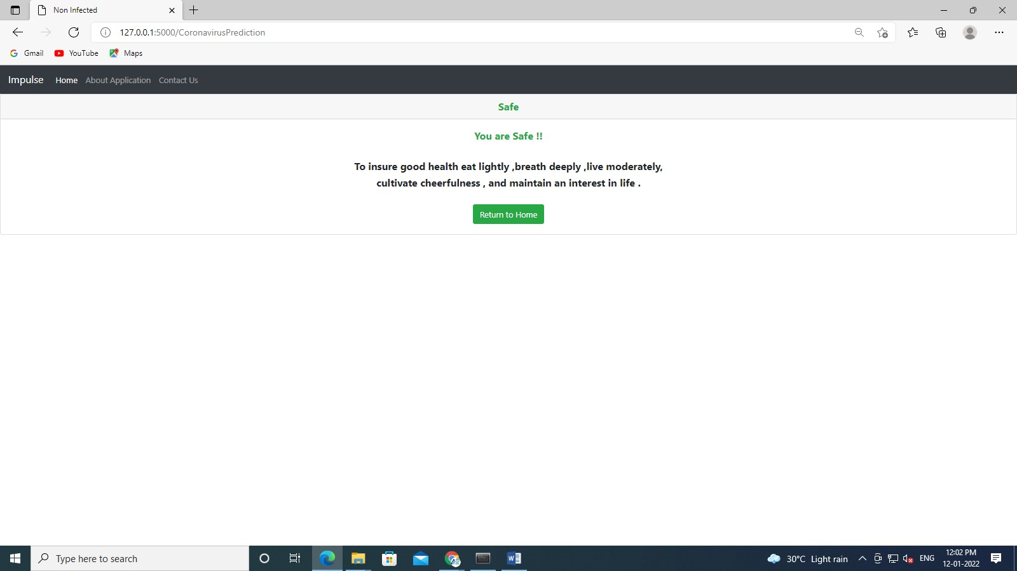

Danger Zone

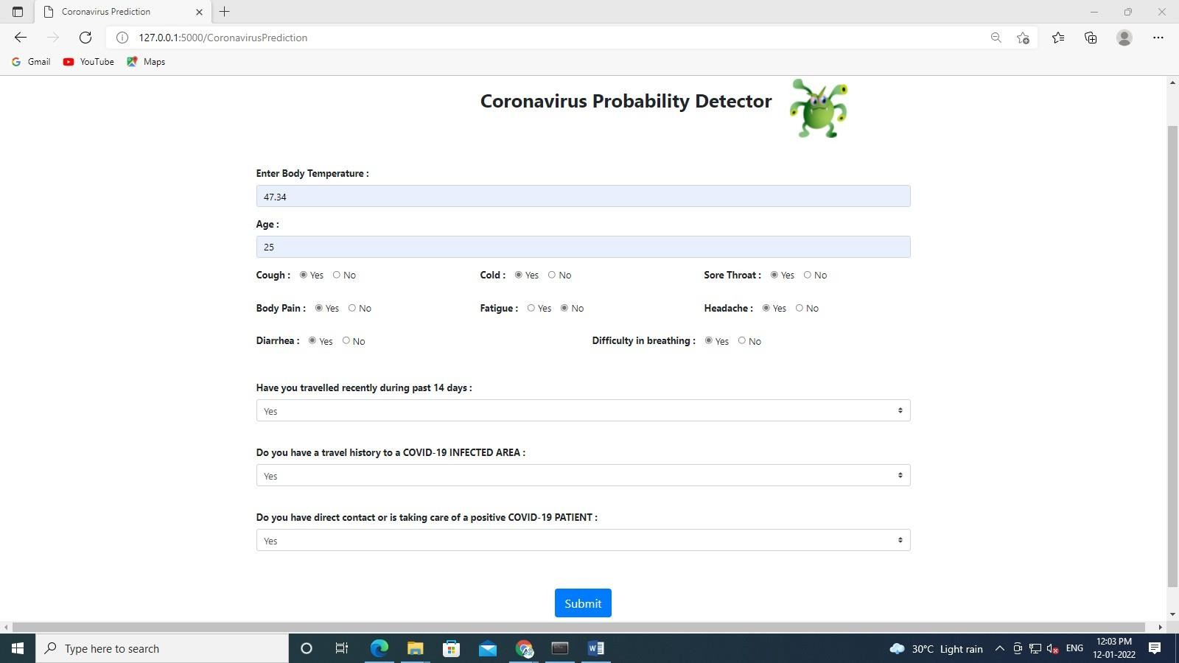

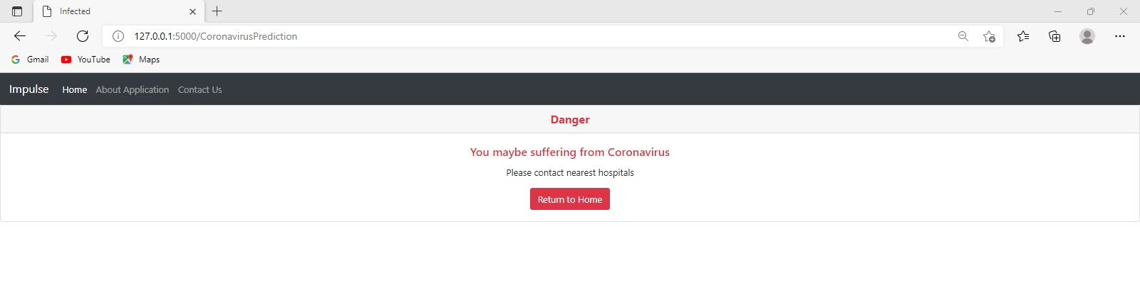

Multiple Disease Prediction Page

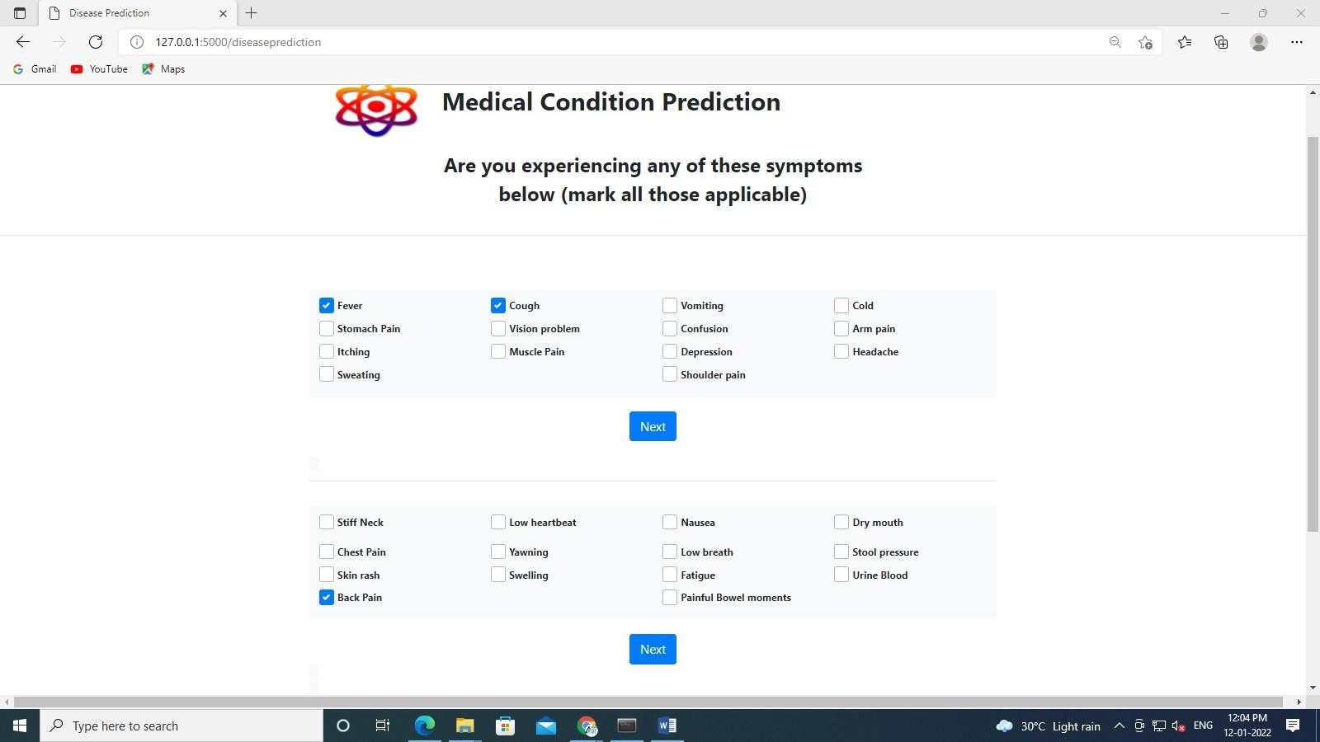
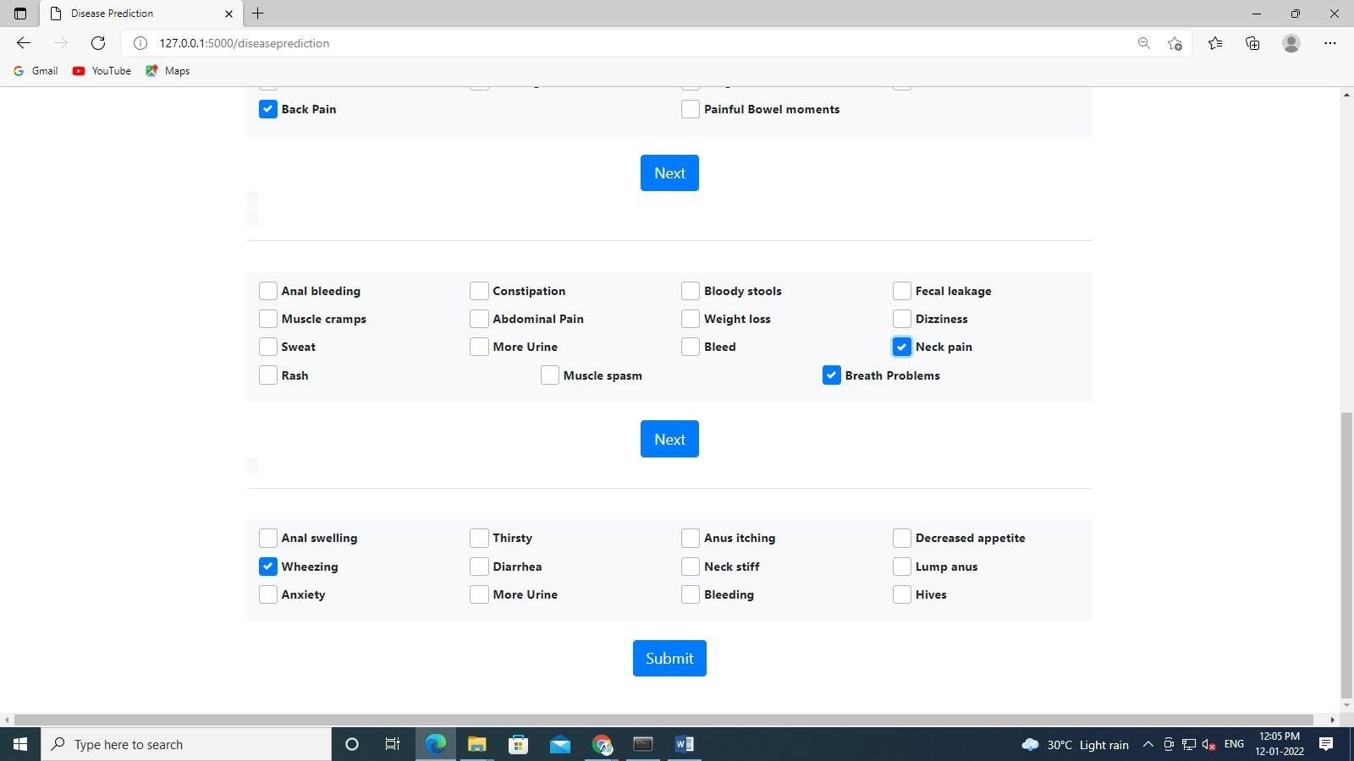

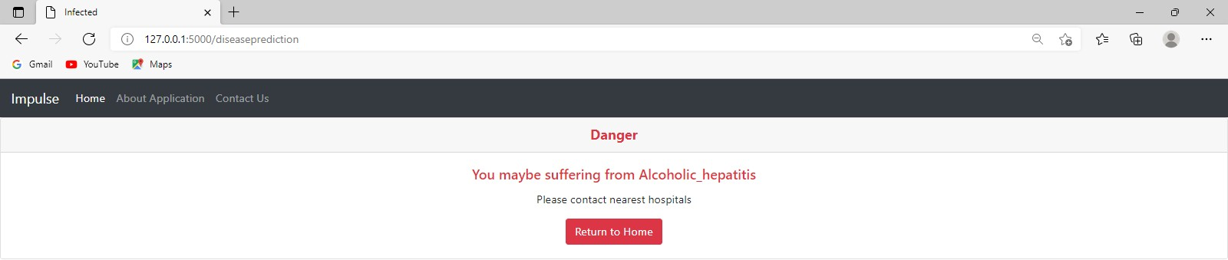

Pneumonia
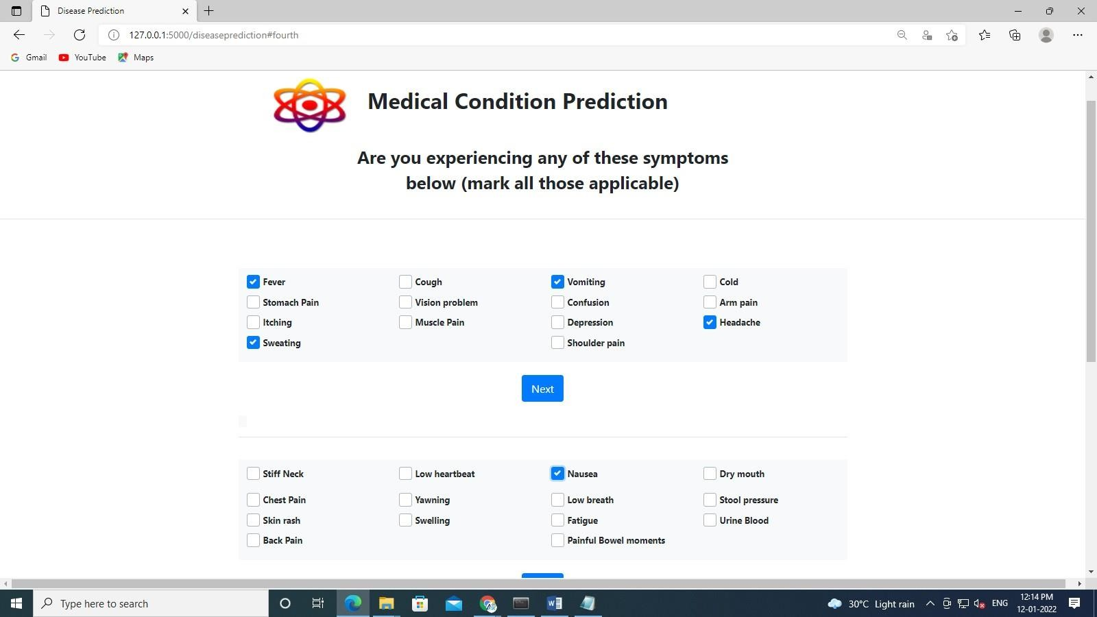

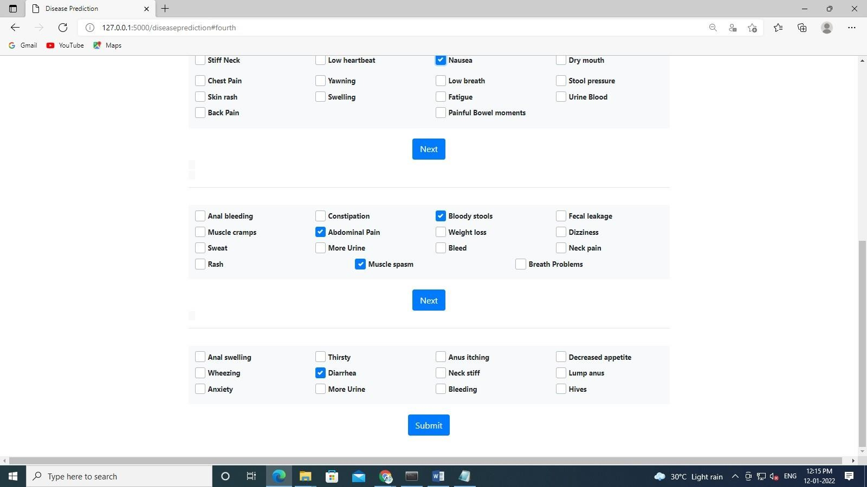

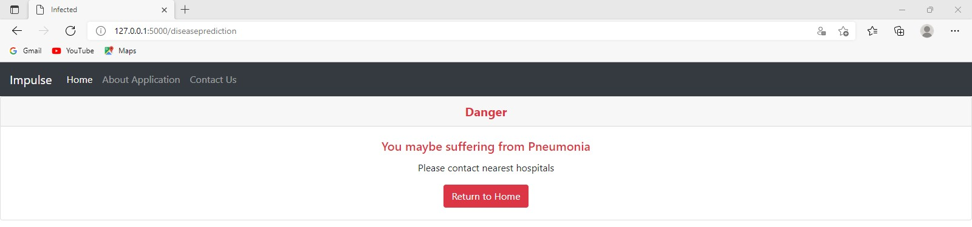

Chronic Kidney Disease Detection Page Danger Zone

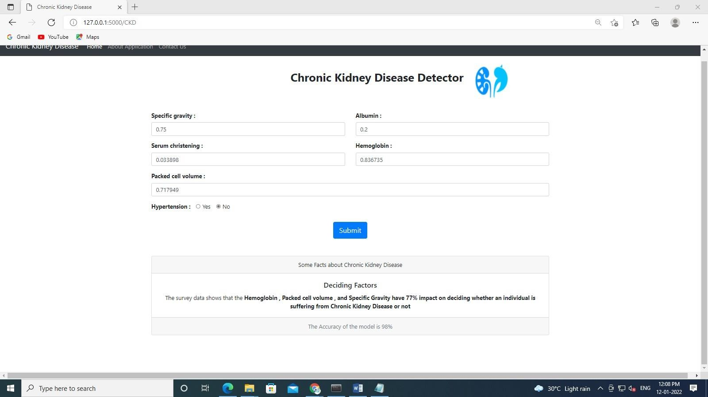

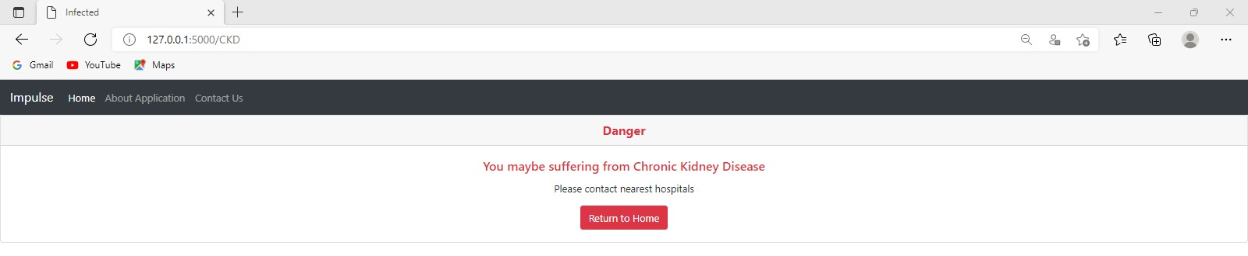

Safe Zone
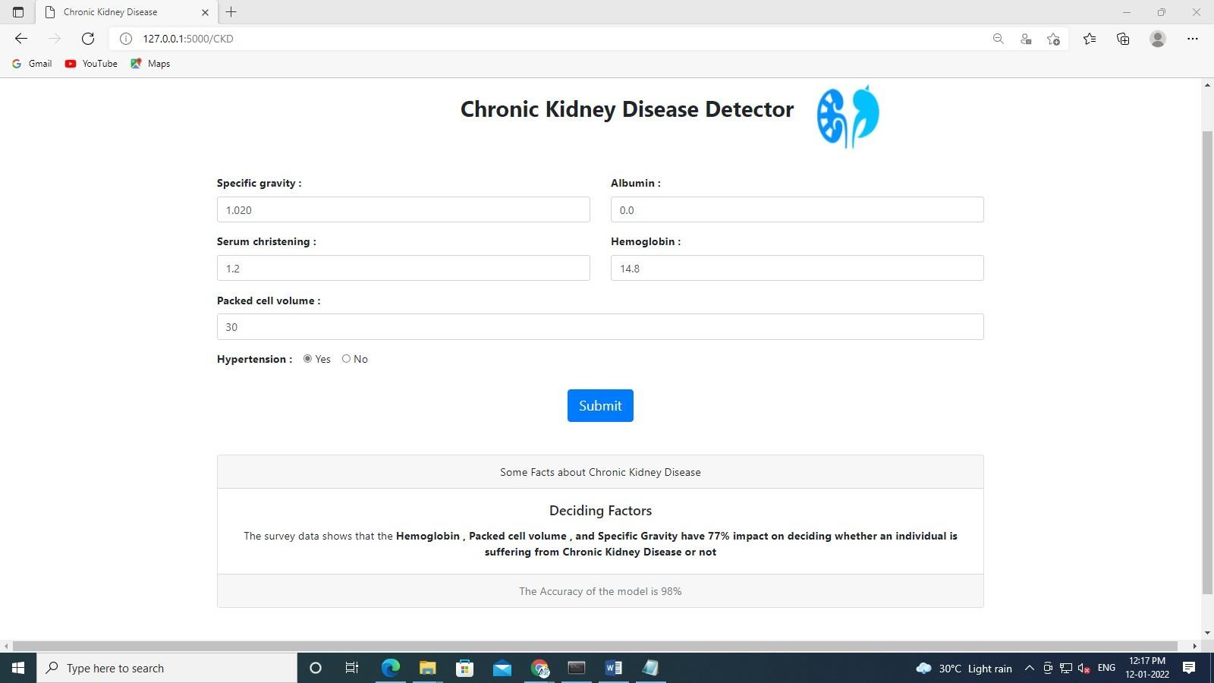

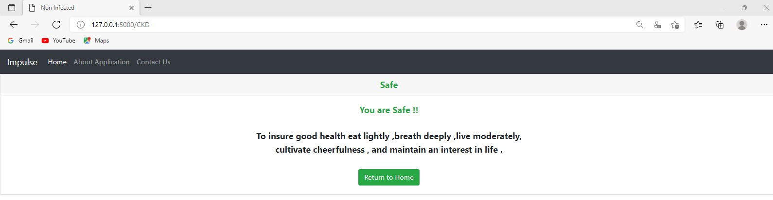

Heart Disease Detection Page Safe Zone

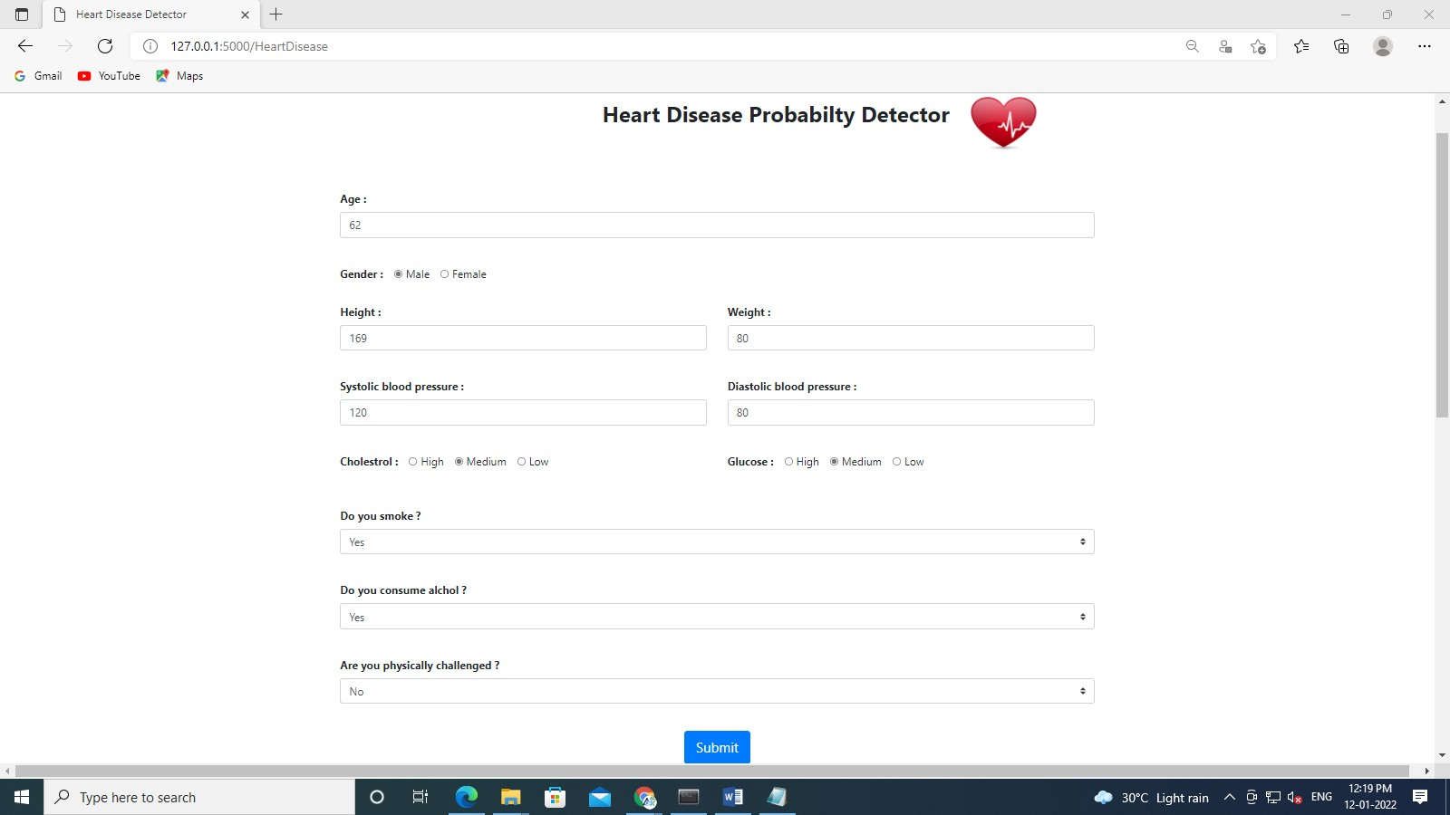

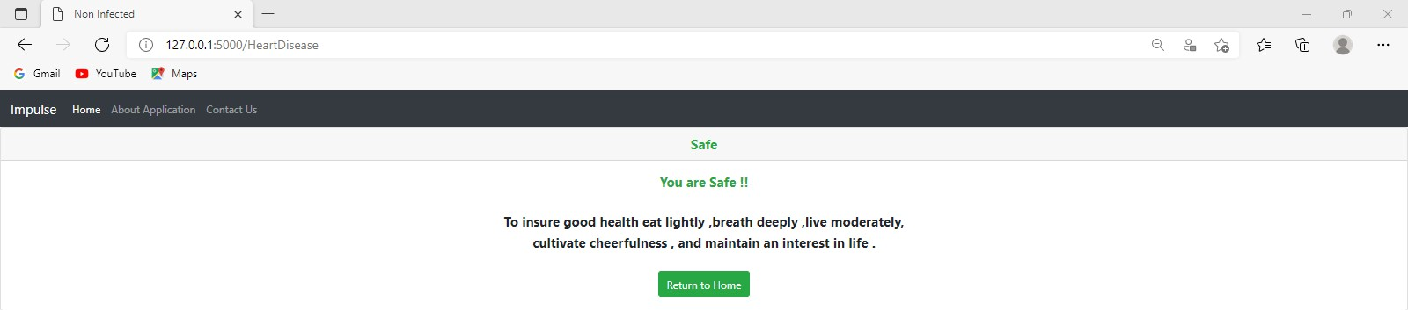
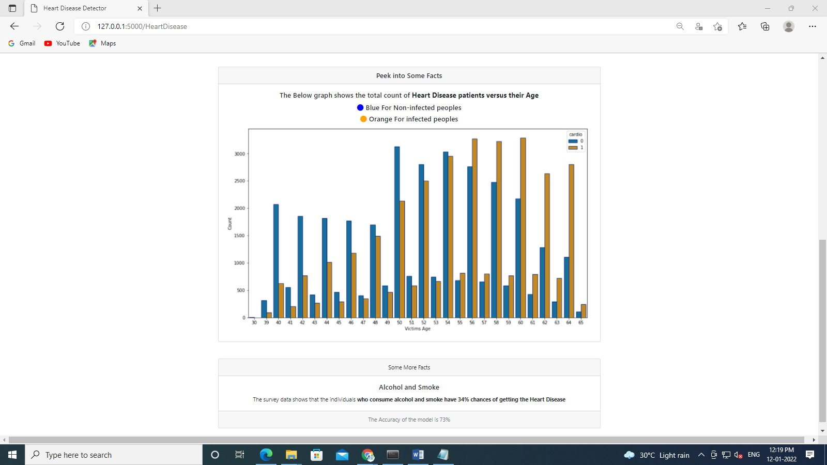

Danger Zone

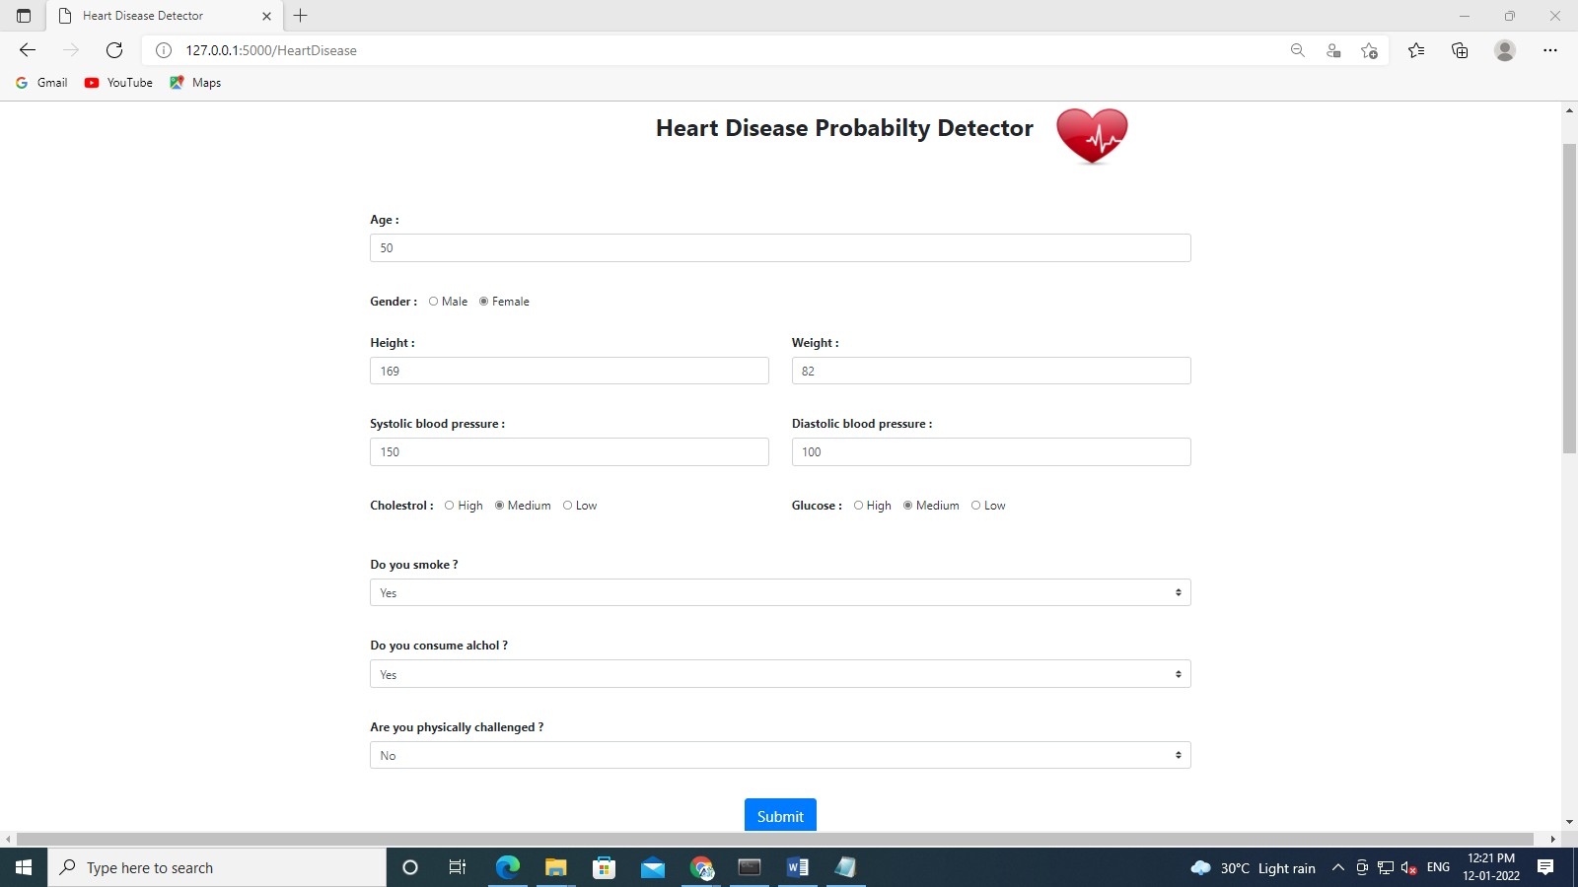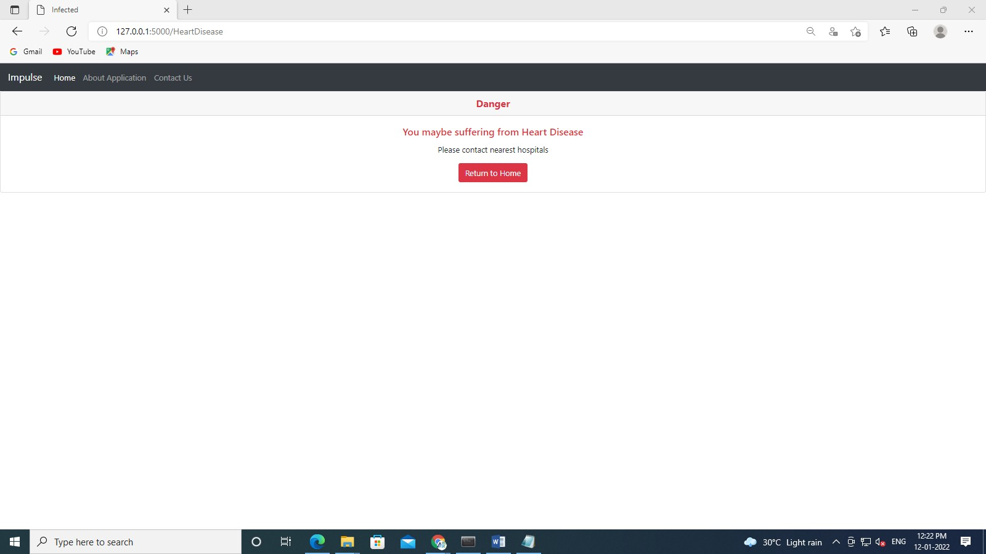

Chapter 8.

REFERENCES

- A. Singh et al., "Heart Disease Prediction Using Machine Learning
Algorithms", 2020 International Conference on Electrical and Electronics Engineering (ICE3), pp. 452-457, February 2020.
- A Narin, C Kaya and Z. Pamuk, "Automatic detection of coronavirus disease (COVID-19) using x-ray images and deep convolutional neural networks", Mar 2020.
- Rajesh. Ranjan, "Predictions for COVID-19 outbreak in India using Epidemiological models", 2020.
- Mohan Senthilkumar, Chandrasegar Thirumalai and Gautam Srivastava, "Effective heart disease prediction using hybrid machine learning techniques", IEEE Access, vol. 7, pp. 81542-81554, 2019.
- Mohan Senthilkumar, Chandrasegar Thirumalai and Gautam Srivastava, "Effective heart disease prediction using hybrid machine learning techniques", IEEE Access, vol. 7, pp. 81542-81554, 2019.
- M. Bayati, S. Bhaskar and A. Montanari, "Statistical analysis of a low cost method for multiple disease prediction", Statistical Methods Med. Res., vol. 27, no. 8, pp. 2312-2328, 2018.
- A. K. Shrivas and S. Kumar Sahu, "Classification of Chronic Kidney
Disease using Feature Selection Techniques", IJCSE, vol. 6, no. 5, pp. 649- 653, 2018.

Chapter 9.

Student Profile

Name : PRERNA KAPOOR
Roll No: 21012011018
Education: Bachelor of Technology (B.Tech) in Information Technology (IT)
Institute: B.S. Anangpuria Institute of Technology and Management, affiliated to J.C. Bose University of Science and Technology, YMCA

Skills
- Programming & Analytics: Python, SQL, R, Machine Learning, Natural Language Processing (NLP)
- Business Intelligence Tools: Power BI, Advanced Excel, Data Visualization
- Cloud & Platforms: Azure Cloud, IBM Cloud, AWS
- Data Handling: Data Cleaning, Preprocessing, Feature Selection, Statistical Analysis
- Development Tools: Visual Studio Code, Jupyter Notebook, GitHub
- Other Skills: Web Scraping, Prompt Engineering, Full-Stack Basics
- Strong in problem-solving, critical thinking, and effective communication

Roles & Responsibilities
- Data Collection and Management
- Collected data from structured and unstructured sources, including APIs, web scraping, and Excel/CSV files
- Ensured data accuracy through validation and storage procedures
- Data Cleaning and Preparation
- Preprocessed raw datasets by handling null values, outliers, and converting data formats
- Data Analysis and Interpretation
- Conducted Exploratory Data Analysis (EDA) to discover trends, patterns, and hidden insights
- Applied ML models like Logistic Regression and Decision Trees for prediction tasks
- Data Visualization
- Built interactive dashboards and visual reports using Power BI and Matplotlib
- Represented KPIs and analytics clearly for technical and non-technical audiences
- Reporting and Communication
- Prepared reports and presentations to summarize project results
- Collaborated with teams to deliver actionable, data-driven recommendations
- Continuous Improvement
- Regularly upskilled in the fields of ML, cloud computing, and BI through self-learning and certifications

Internship Experience
Labmentix Edtech Pvt. Ltd.
Role: Data Science Intern
Duration: 15th January 2025 – 15th June 2025 (6 Months)
Tools Used: Python, SQL, Machine Learning, Power BI
Key Projects:
- Multiple Disease Prediction System: Built a machine learning model to predict diseases based on symptoms, using logistic regression and classification methods.
- Glassdoor Job Analysis: Analyzed job data to extract trends in salary, job roles, and skill requirements across industries.
- MediBuddy Health Data Analytics: Interpreted large-scale healthcare data to offer insights on patient behavior and service usage patterns.
- Prime Video Dataset Analysis: Conducted genre-wise, user engagement, and performance analysis using Python and visual dashboards.

Achievements
- Designed a Power BI dashboard used in project reports with real-time KPIs from 500+ user survey data
- Automated data cleaning tasks to reduce preprocessing time by 30%
- Integrated multiple datasets to enhance model accuracy and insight depth
- Successfully completed 15+ academic and industry-based projects
- Recognized for providing actionable recommendations in real-time scenarios

